Ann Liberman 3/6/2021

CISC 3140

**Lab #4**

**Part I. Connecting to BC’s Web Lab Linux Server using SSH**

1. Download [Putty](https://www.chiark.greenend.org.uk/~sgtatham/putty/latest.html). Putty is a free open-source terminal emulator. (This step only needs to be done once).
2. Look up your credentials (username & password), which are distributed by the school.
3. Open Putty. The screen should look like this:  
     
     
     
     
     
     
     
   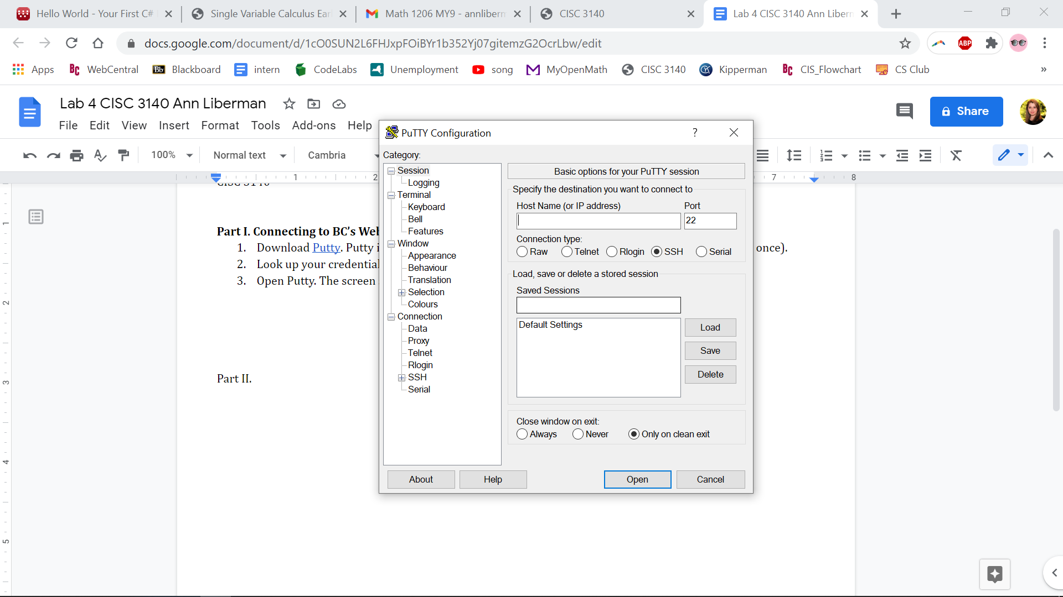

1. Type or paste one of the below IP addresses

in the ‘Host Name’ field:

* 146.245.252.28
* 146.245.252.29
* 146.245.252.30
* 146.245.252.31
* 146.245.252.150

1. Click ‘Open’ on the bottom right
2. A login screen will appear, prompting user to input the username. It should look like this:   
     
     
     
     
     
   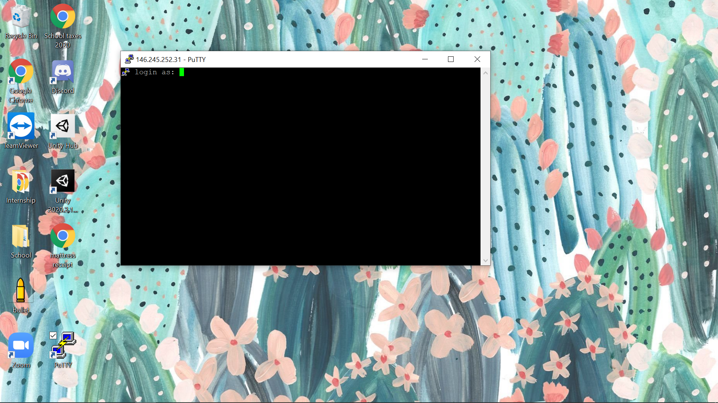
3. Input the username and hit the ‘enter’ key. You will then be prompted to input a password. *Please note, the password may not be displayed as you type, however, if the password is correct, you should get a screen with access to the command line.
4. Once you see this, it means you have made it in successfully:

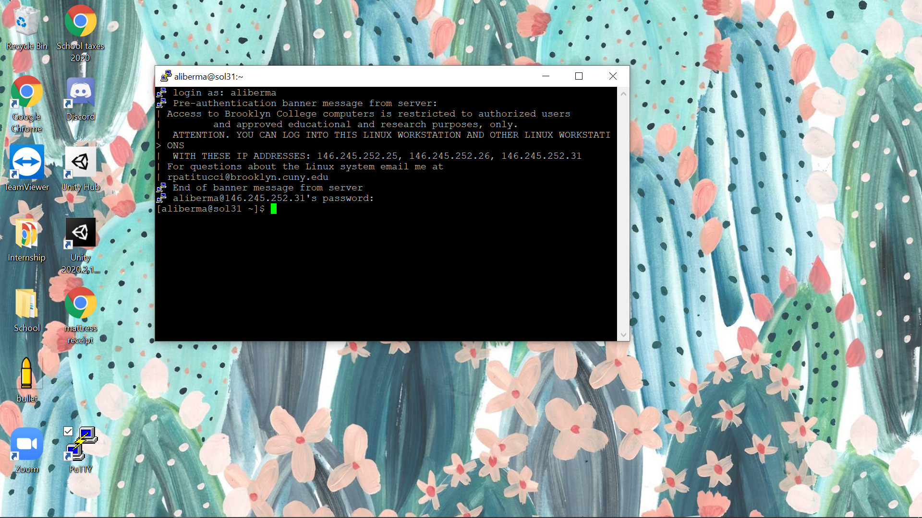

**Part II. Looking Up Information for Linux Programs**

Here are some programs, and what they do:

* **curl** allows you to transfer a url (to or from a remote host.) It can be useful for troubleshooting and downloads.
  + Location: curl: /usr/bin/curl /usr/share/man/man1/curl.1.gz
  + The syntax for **curl** is: curl [options] [url]

Examples:

curl google.com

curl -L google.com

curl -T google.com

* **wget** is a noninteractive network downloader. It allows you to download files from the web using HTTP, HTTPS, and FTP protocols.
  + Location: wget: /usr/bin/wget /usr/share/man/man1/wget.1.gz
  + The syntax for **wget** is: $ wget [options] [url]

Example:

wget <http://apache.cs.utah.edu/tomcat/tomcat-9/v9.0.20/bin/apache-tomcat-9.0.20.tar.gz>

* **subversion** is a tool for version control, typed as svn often. svn has a number of subcommands, or options to use it with.
  + Location: svn: /usr/bin/svn /usr/share/man/man1/svn.1.gz
  + The following are all valid ways to use **svn**:

svn -vq status myfile

svn status -v -q myfile

svn -q status -v myfile

svn status -vq myfile

svn status myfile -qv

* **awk** is used for manipulating data and generating reports using variables, numeric functions, string functions, and logical operators.
  + Location: awk: /usr/bin/awk /usr/libexec/awk /usr/share/awk /usr/share/man/man1p/awk.1p.gz /usr/share/man/man1/awk.1.gz
  + What can we do with **awk**?
    - Scan a file line by line
    - Splits each input line into fields
    - Compares input line/fields to pattern
    - Performs action(s) on matched lines
  + Syntax: awk options 'selection _criteria {action }' input-file > output-file
* **java** starts a java application. You can type arguments into the command line, and you can execute a java program from the command line.
  + Location: java: /usr/bin/java /usr/lib/java /etc/java /usr/share/java /usr/share/man/man1/java.1.gz
  + For example, I have a Sum.java program that I wrote and saved, which returns the sum of two ints. I can type: java Sum 3 6 and the program returns the following text: The sum is 9
* **git** is a Perl interface to the Git version control. The command line is the only place you can run all Git commands,as most GUIs implement only a subset of Git functionality.
  + Location: git: /usr/bin/git /usr/share/man/man1/git.1.gz
* **guile** is the GNU Project Extension Language. It is a dialect of the Scheme programming language. That means that Guile is designed as a library you can include into your own project and make the interpreter run code within it; additionally, you can provide special procedures in this Guile environment that interface to the core of your application. This way, Scheme scripts written by a user can manipulate stuff “within” your application.
  + Location: guile: /usr/bin/guile /usr/lib64/guile /usr/share/guile /usr/share/man/man1/guile.1.gz
  + Syntax: guile [OPTION]... [FILE]...
* **gimp** is an image manipulation and paint program
  + Location: gimp: /usr/bin/gimp /usr/lib64/gimp /etc/gimp /usr/share/gimp /usr/share/man/man1/gimp.1.gz
  + Syntax: gimp [OPTION…] [FILE|URI...]
* **inkscape** is an SVG (Scalable Vector Graphics) editing program
  + Location: inkscape: /usr/bin/inkscape /usr/lib/inkscape /usr/share/inkscape /usr/share/man/man1/inkscape.1.gz
* **mysql** is the MySQL command-line tool. It is a simple SQL shell with input line editing capabilities. It supports interactive and noninteractive use. Query results are either presented in an ASCII-table format, or in tab-separated format depending on how it is being used.
  + Location: mysql: /usr/bin/mysql /usr/lib64/mysql /usr/share/mysql /usr/share/man/man1/mysql.1.gz
  + Syntax: mysql db_name < script.sql > output.tab
* **zip** is used to package and compress (archive) files. The main purpose of zip is to create a zip archive and add files to it.
  + Location: zip: /usr/bin/zip /usr/share/man/man1/zip.1.gz
  + Syntax: zip [options] zipfile files_list
  + Syntax for Creating a zip file: $zip myfile.zip filename.txt
* **head** can copy and/or output the first part of files
* **tail** can copy and/or output the last part of files

**Some additional shortcuts I learned include**:

* $PATH will show you all the paths on your machine that the shell will search (for programs). Paths are a way to name the location of a file on your computer, separated by slashes.
* pwd is, print working directory. It tells you where you currently are / your current path.
* cd/[*insert location here*] allows you to change the directory you’re in. For example; cd/home will take you to your home directory.
* dot and dot dot help you easily navigate around the system. dot means the current directory and dot dot means the parent directory.
* ls will list the programs in the current directory. When I input ls, I got back the following:

cis3115 CS3115 HalloWorld.class HalloWorld.java nano.save numbers.text Phonebook0.class Phonebook0.java Sum.class Sum.java (These are some programs I wrote last semester for my CIS3115 class).

* ~ or the “tilde,” will bring you to your home directory. For example: cd~
* - or the “dash,” will bring you to your previous directory. For example: cd-
* mv, or move, lets you rename a file
* rm, or remove, lets you remove a file
* rmdir, or remove directory, lets you remove a directory (as a safety mechanism, I believe it will only let you delete an empty directory)
* mkdir, or make directory, lets you make a new directory
* Ctrl + l allows you to clear the screen
* # means run this is root
* sudo means “to do as the super user”
* sudo su will run the program as administrator
* tee lets you send to file and print to screen
* xdg-open will open a file in the appropriate program

**Part III. Using the command line to write up the above notes (using some text editor):**

Shortcuts:

1. Type nano [fileName] to open an existing file, or to create a new file, and then open the text editor window
   1. I wrote: nano Lab4
   2. (If you want to open a file with the cursor on a specific line and character use the following syntax: nano +line_number,character_number filename)
2. To move the cursor to a specific line and character number, use the Ctrl+_
3. To cut type Ctrl+K
4. To past type Ctrl+U
5. When you try to exit the nano program, before it returns to the command line you are asked to save your work. You can save the file and then return to it as you please, by typing nano [FileName], or in this case, nano Lab4, and the below text file will open: 